**DIGITAL SYSTEMS**

**PRACTICUM 8**



**By:**

**ARIA WIDIYO NOVIYANTO**

**NIM: L200183043**

**INFORMATION TECHNOLOGY**

**FACULTY OF COMMUNICATION AND INFORMATICS**

**UNIVERSITY OF MUHAMMADIYAH SURAKARTA**

**Experiment 1**

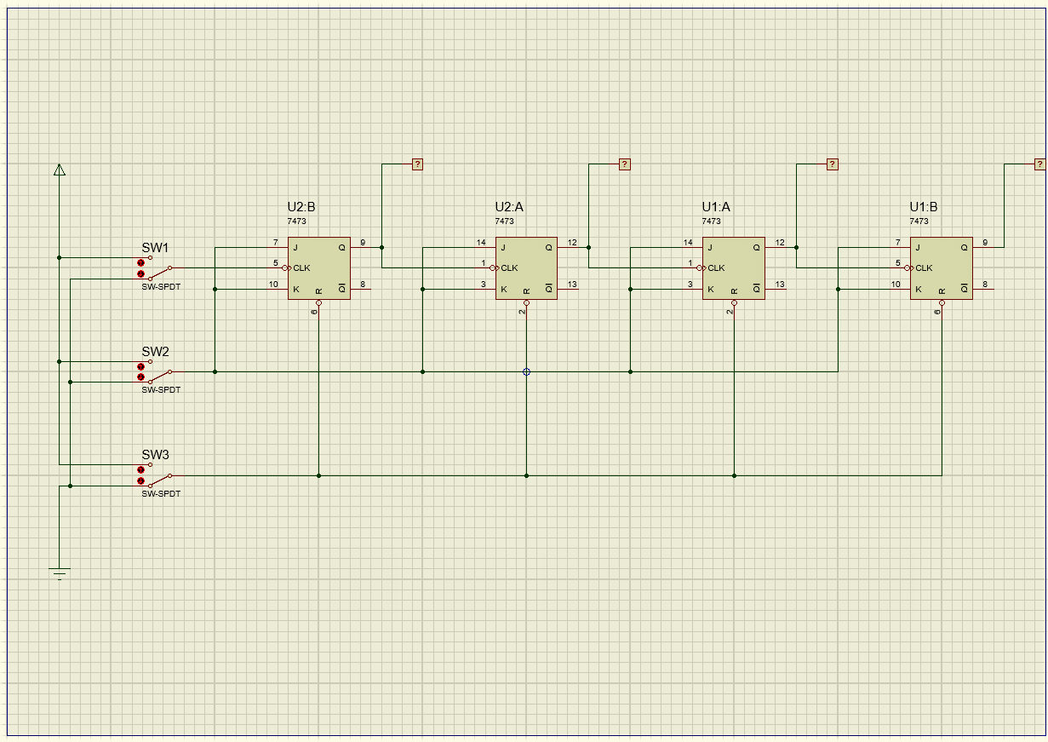

Picture 1.1. JK flip-flop combination

1. Simulation table

|  |  |  |  |  |  |  |  |
| --- | --- | --- | --- | --- | --- | --- | --- |
|  | **INPUT** | | | **OUTPUT** | | | |
| **CLEAR** | **JK** | **CLK** | **A** | **B** | **C** | **D** |
| **1** | 1 | 1 | 0 | 0 | 0 | 0 | 0 |
| **2** | 1 | 1 | 1 | 0 | 0 | 0 | 0 |
| **3** | 1 | 1 | 0 | 0 | 0 | 0 | 1 |
| **4** | 1 | 1 | 1 | 0 | 0 | 0 | 1 |
| **5** | 1 | 1 | 0 | 0 | 0 | 1 | 0 |
| **6** | 1 | 1 | 1 | 0 | 0 | 1 | 0 |
| **7** | 1 | 1 | 0 | 0 | 0 | 1 | 1 |
| **8** | 1 | 1 | 1 | 0 | 0 | 1 | 1 |
| **9** | 1 | 1 | 0 | 0 | 1 | 0 | 0 |
| **10** | 1 | 1 | 1 | 0 | 1 | 0 | 0 |
| **11** | 1 | 1 | 0 | 0 | 1 | 0 | 1 |
| **12** | 1 | 1 | 1 | 0 | 1 | 0 | 1 |
| **13** | 1 | 1 | 0 | 0 | 1 | 1 | 0 |
| **14** | 1 | 1 | 1 | 0 | 1 | 1 | 0 |
| **15** | 1 | 0 | 0 | 0 | 1 | 1 | 0 |
| **16** | 1 | 0 | 1 | 0 | 1 | 1 | 0 |
| **17** | 1 | 1 | 0 | 0 | 1 | 1 | 1 |
| **18** | 1 | 1 | 1 | 0 | 1 | 1 | 1 |
| **19** | 0 | 1 | 0 | 0 | 0 | 0 | 0 |
| **20** | 0 | 1 | 1 | 0 | 0 | 0 | 0 |

1. What is the function of
   1. Switch CLK:

Answer: Functions to continue to the next binary number at the output.

* 1. Switch JK:

Answer: Functions as an increase in binary numbers if the value is 1, if the JK input is 0 then the output of the binary number is not forwarded or remains the last output.

* 1. Switch CLEAR:

Answer: Functions to display the binary number output, if the CLEAR input is 0 then all the output results are 0

1. Conclusion

If the CLEAR input is 0 then all the output results are 0, if the JK input is 0 then the output of the binary number is not forwarded or remains the last output.

**Experiment 2**

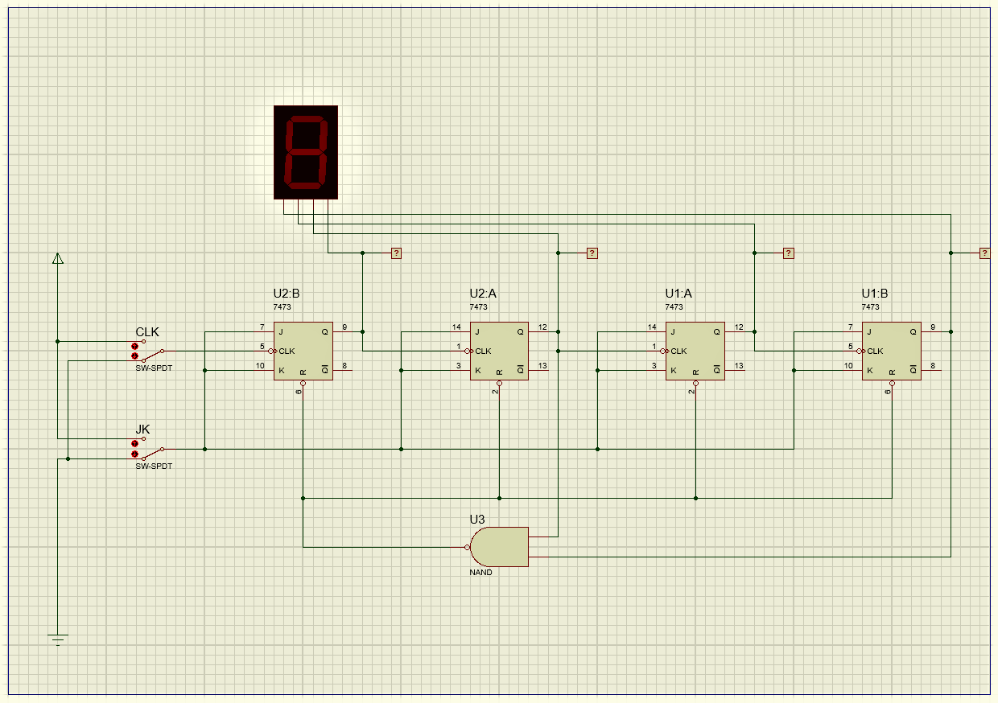

Picture 2.1. JK flip-flop combination

1. Simulation table

|  |  |  |  |  |  |  |
| --- | --- | --- | --- | --- | --- | --- |
|  | **INPUT** | | **OUTPUT** | | | |
| **JK** | **CLK** | **A** | **B** | **C** | **D** |
| **1** | 1 | 0 | 0 | 0 | 0 | 0 |
| **2** | 1 | 1 | 0 | 0 | 0 | 0 |
| **3** | 1 | 0 | 0 | 0 | 0 | 1 |
| **4** | 1 | 1 | 0 | 0 | 0 | 1 |
| **5** | 1 | 0 | 0 | 0 | 1 | 0 |
| **6** | 1 | 1 | 0 | 0 | 1 | 0 |
| **7** | 1 | 0 | 0 | 0 | 1 | 1 |
| **8** | 1 | 1 | 0 | 0 | 1 | 1 |
| **9** | 1 | 0 | 0 | 1 | 0 | 0 |
| **10** | 1 | 1 | 0 | 1 | 0 | 0 |
| **11** | 1 | 0 | 0 | 1 | 0 | 1 |
| **12** | 1 | 1 | 0 | 1 | 0 | 1 |
| **13** | 1 | 0 | 0 | 1 | 1 | 0 |
| **14** | 1 | 1 | 0 | 1 | 1 | 0 |
| **15** | 1 | 0 | 0 | 1 | 1 | 1 |
| **16** | 1 | 1 | 0 | 1 | 1 | 1 |
| **17** | 1 | 0 | 1 | 0 | 0 | 0 |
| **18** | 1 | 1 | 1 | 0 | 0 | 0 |
| **19** | 1 | 0 | 1 | 0 | 0 | 1 |
| **20** | 1 | 1 | 1 | 0 | 0 | 1 |
| **21** | 0 | 0 | 1 | 0 | 0 | 1 |
| **22** | 0 | 1 | 1 | 0 | 0 | 1 |
| **23** | 1 | 0 | 0 | 0 | 0 | 0 |
| **24** | 1 | 1 | 0 | 0 | 0 | 0 |

1. Conclusion

Functions of CLK switch is to continue to the next binary number at the output. Functions of JK switch is as an increase in binary numbers if the value is 1, if the JK input is 0 then the output of the binary number is not forwarded or remains the last output.

**Experiment 3**

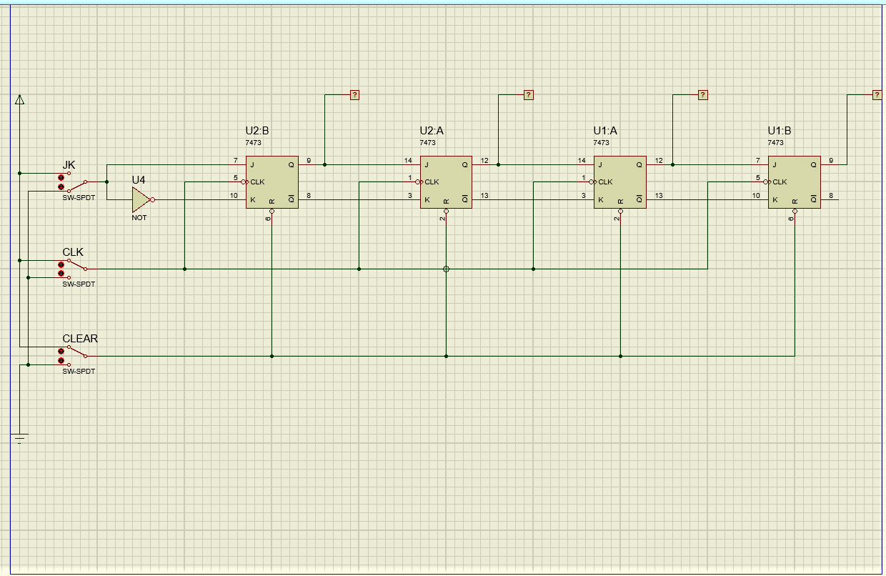

Picture 3.1. JK flip-flop combination

1. Simulation table

|  |  |  |  |  |  |  |  |
| --- | --- | --- | --- | --- | --- | --- | --- |
|  | **INPUT** | | | **OUTPUT** | | | |
| **CLEAR** | **JK** | **CLK** | **A** | **B** | **C** | **D** |
| **1** | 0 | X | - | 0 | 0 | 0 | 0 |
| **2** | 1 | 1 | - | 0 | 0 | 0 | 0 |
| **3** | 1 | 1 | 1 | 0 | 0 | 0 | 0 |
| **4** | 1 | 1 | 2 | 0 | 0 | 0 | 1 |
| **5** | 1 | 1 | 3 | 0 | 1 | 1 | 1 |
| **6** | 1 | 0 | 4 | 0 | 1 | 1 | 1 |
| **7** | 1 | 0 | 5 | 1 | 1 | 1 | 0 |
| **8** | 1 | 0 | 6 | 1 | 0 | 0 | 0 |
| **9** | 1 | 0 | 7 | 1 | 0 | 0 | 0 |
| **10** | 1 | 0 | 8 | 0 | 0 | 0 | 0 |
| **11** | 1 | 1 | 9 | 0 | 0 | 0 | 1 |
| **12** | 1 | 0 | 10 | 0 | 0 | 1 | 1 |
| **13** | 1 | 0 | 11 | 0 | 1 | 1 | 0 |
| **14** | 1 | 0 | 12 | 1 | 1 | 0 | 0 |
| **15** | 1 | 0 | 13 | 1 | 0 | 0 | 0 |

1. Conlusion

If the CLK switch is not connected then all output results will produce 0. If the input value of JK 0 then the output will move to the output part that is located in front of it and the last output part changes to 0 until all output results are 0.